Chapter 11, Problem 92.

As shown in Fig. 11.97, a 550-V feeder line supplies an industrial plant consisting of a motor drawing 60 kW at 0.75 pf (inductive), a capacitor with a rating of 20 kVAR, and lighting drawing 20 kW.

(a) Calculate the total reactive power and apparent power absorbed by the plant.

(b) Determine the overall pf.

(c) Find the current in the feeder line.

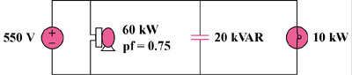

Figure 11.97
For Prob. 11.92.

